**Phase 7: Integration & External Access - Submission Document**

**1. Named Credentials**

*Definition:* Securely store authentication details for external systems.

**Steps:**

1. Setup → Named Credentials → New Named Credential.
2. Enter URL, authentication type, and required credentials.
3. Save and test connection.

**Observation:** Connection to external service successful.

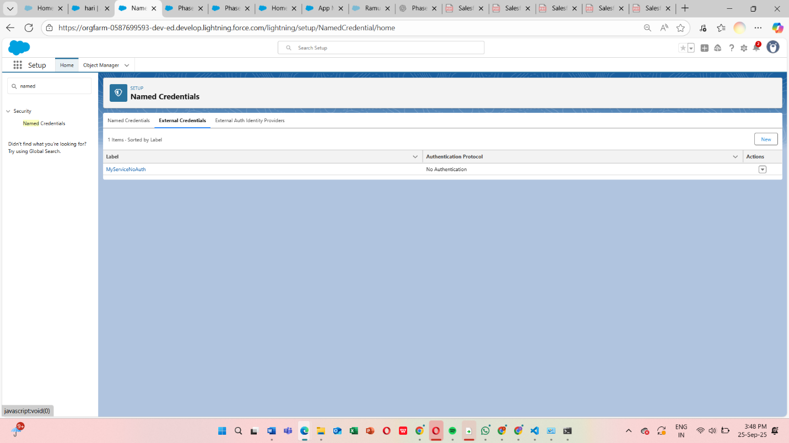

**2. External Services**

*Definition:* Integrate external API services declaratively.

**Steps:**

1. Setup → External Services → Register Service.
2. Import OpenAPI specification.
3. Generate Apex actions.
4. Test generated actions in Flow or Apex.

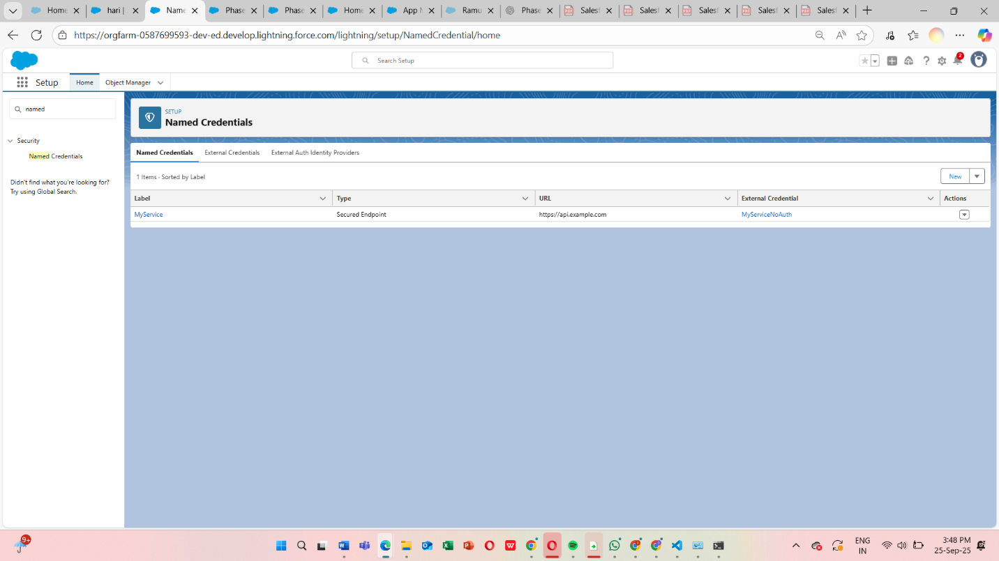

**3. Web Services (REST/SOAP)**

*Definition:* Use REST or SOAP endpoints for integration.

**Steps:**

1. Create Apex class with @RestResource for REST or WSDL2Apex for SOAP.
2. Test endpoint using Postman or Salesforce.
3. Verify request and response.

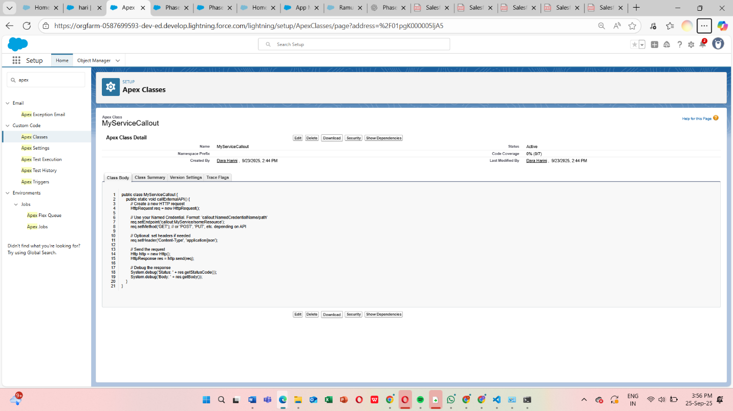

**4. Callouts**

*Definition:* Make HTTP requests from Apex to external systems.

**Steps:**

1. Create Apex class with HttpRequest/HttpResponse.
2. Add Remote Site Settings for external endpoint.
3. Execute callout and verify response.

**Code Snippet:**

HttpRequest req = new HttpRequest();

req.setEndpoint('https://api.example.com/data');

req.setMethod('GET');

Http http = new Http();

HTTPResponse res = http.send(req);

System.debug(res.getBody());

**5. Platform Events**

*Definition:* Custom events used for event-driven architecture.

**Steps:**

1. Setup → Platform Events → New Platform Event.
2. Add custom fields.
3. Publish event via Apex or Process Builder.
4. Subscribe using Trigger, Flow, or LWC.

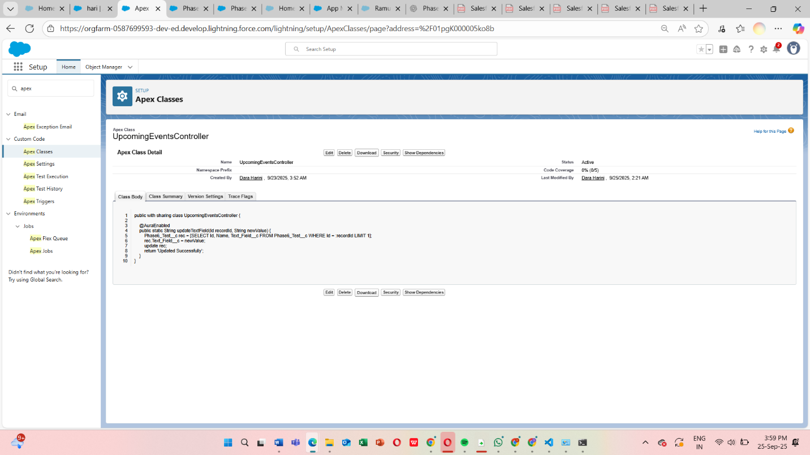

**6. Change Data Capture (CDC)**

*Definition:* Capture changes in Salesforce records in real time.

**Steps:**

1. Setup → Change Data Capture → Enable for required objects.
2. Subscribe using CometD client or Apex Trigger.
3. Verify record change notifications.

**7. Salesforce Connect**

*Definition:* Access external data in real time without storing in Salesforce.

**Steps:**

1. Setup → External Data Sources → New.
2. Configure authentication and object mappings.
3. Create External Object.
4. Verify external data accessible in Salesforce.

**8. API Limits**

*Definition:* Monitor the number of API requests to prevent hitting governor limits.

**Steps:**

1. Setup → System Overview → API Usage.
2. Monitor limits during callouts and integrations.
3. Adjust integration frequency if needed.

**9. OAuth & Authentication**

*Definition:* Secure authentication for external systems via OAuth.

**Steps:**

1. Setup → Connected Apps → New.
2. Configure OAuth scopes and callback URL.
3. Test OAuth flow using external system or Postman.

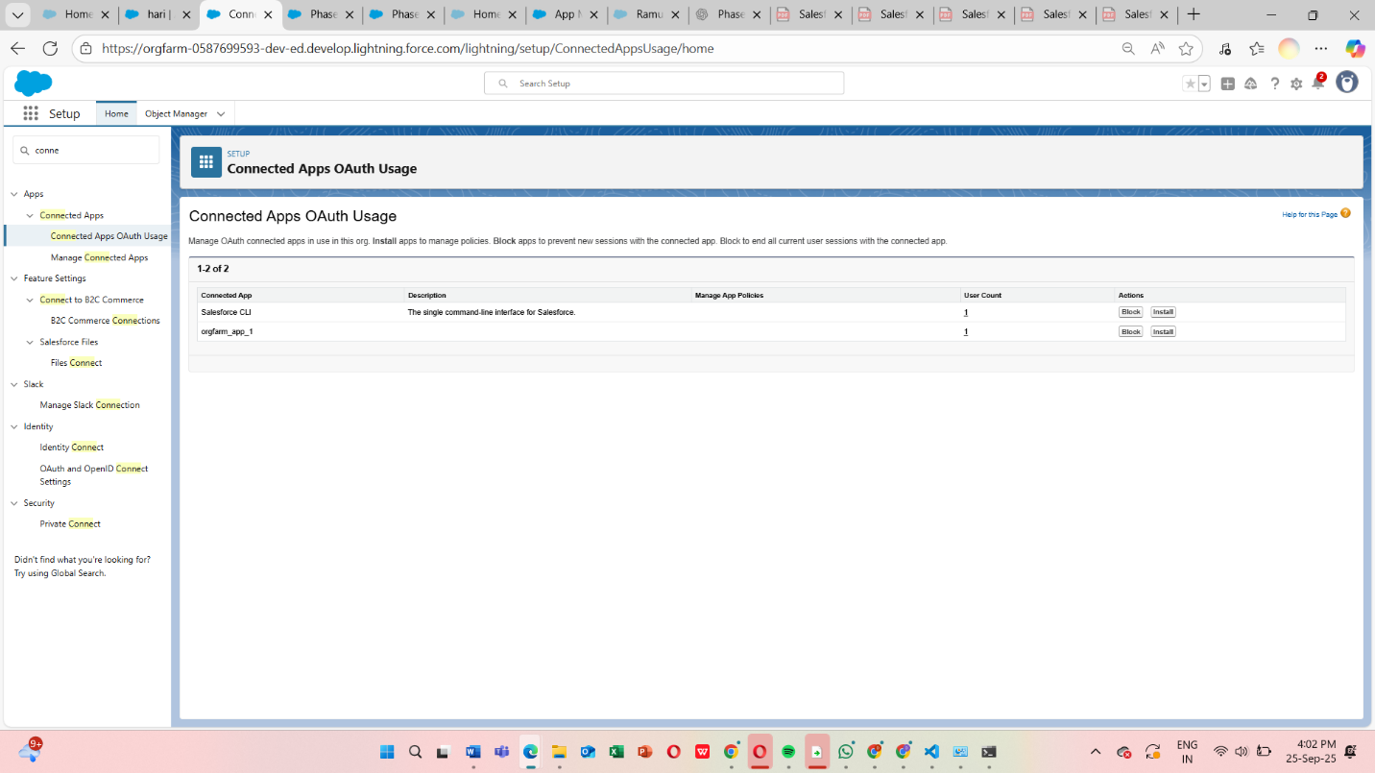

**10. Remote Site Settings**

*Definition:* Allow Salesforce to make callouts to external URLs.

**Steps:**

1. Setup → Remote Site Settings → New.
2. Enter external URL and name.
3. Save and verify callout success.

